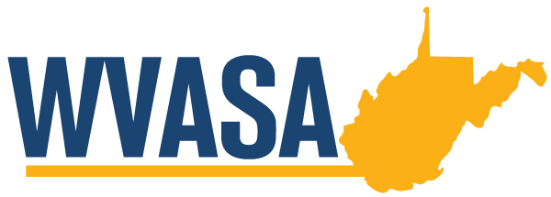
WVASA Winter Conference
January 26 – 27, 2023
Bridgeport Conference Center
Fairmont, WV

Thursday, January 26, 2022

9:00 a.m. REGISTRATION
10:00 a.m. OPENING OF SEMINAR
Dr. Ryan Saxe
Superintendent,Cabell County Schools
WVASA Vice-President
GREETINGS
Superintendent,
10:00 a.m. SESSION 1: From Silicon Valley CEO to University President – A Fireside Chat with Marshall University President Brad. D Smith
Presiding:
Superintendent,

11:00 a.m. BREAK
11:15 a.m. SESSION 1- Continued
12:15 a.m. LUNCH
12:45 p.m. SESSION 2: School Security Cameras – What’s Permitted?
& Medical Cannabis – Considerations for School District Policies for Employees and Students
Presiding:
Superintendent,
Presenter: Jason Long and Jacob Manning
Dinsmore & Shohl LLP

1:45 BREAK
2:00 p.m. SESSION 2: Continued

2:30 p.m. SESSION 3: Mandatory Reporting – When Should an Employee be Put on Leave or Reassigned
Presiding:
Superintendent,
Presenter: Chip Williams
Pullin, Flanagan, Brown, & Poe, PLLC

Friday, January 27, 2022

7:30 – 8:45 a.m. BREAKFAST
8:45- 9:00 a.m. Morning Entertainment
9:00 a.m. SESSION 5: Investigating and Responding to Suspected Employee Misconduct
&
Inappropriate Use of Social Media by Employees and Students
Presiding: Joetta Basile
Superintendent, Monroe County Schools
Presenter: Howard Seufer
Bowles Rice LLP
10:30 am. BREAK
10:45 a.m. WVASA Membership Meeting
Presiding: Adam Cheeseman
Superintendent, Doddridge County Schools
WVASA President
11:30 a.m. Conference Concludes

THANK YOU FOR JOINING US FOR THE
WVASA WINTER CONFERENCE!

WE HOPE YOU WILL PLAN TO ATTEND THE 2023 WVASA SUMMER CONFERENCE
JUNE 20 – 23, 2023 at
GLADE SPRINGS Resort

